

**ROBOTICS PROJECT REPORT**

**SMART HOME SYSTEM**

**SUPERVISED BY:**

MR.SUPUN ASANGA

**GROUP MEMBERS**

FATHIMA NISKA - GAHDSE233F-010

UVINDU VISHMINA -GAHDSE233F-011

IMESHA SHAMINDI -GAHDSE233F-012

# **ABSTRACT**

In this report, we introduce a smart home automation system designed to revolutionize home convenience and energy efficiency. The primary objective of this system is to establish an intelligent environment that can automatically manage fan and lighting operations in response to human presence and ambient lighting conditions. To improve its functionality, the system integrates a GSM (Global System for Mobile Communications) module, which is able to send real-time notifications to designated people whenever specific events occur.

To achieve these goals, our project uses a diverse range of hardware components and software modules that are meticulously selected and integrated for optimal performance. Through rigorous testing and refinement, we have developed an innovative and user-friendly solution that is poised to redefine modern living standards.

This report provides a detailed overview of our project, describing the methodologies used, challenges faced and successful results achieved. By sharing our insights and experiences, we aim to contribute to the advancement of smart home technology and encourage future innovation in this exciting field.

# **ACKNOWLEDGEMENT**

This note to acknowledge was created to express our gratitude and appreciation to everyone who supported us and advised us in various ways throughout the course of this project. First and foremost, we would like to express our gratitude to Mr. Supun Asanga for his invaluable advice and constant encouragement throughout the project.

We would like to show gratitude to our friends and all those who directly and indirectly contributed to the successful completion of this project. Finally, we would like to express our gratitude to our classmates and those who assisted us in finishing this project.

**Table of Contents**

**ABSTRACT** 2

**ACKNOWLEDGEMENT** 3

**CHAPTER 1- INTRODUCTION** 5

**CHAPTER 1.1- OBJECTIVES** 6

**CHAPTER 2- METHODOLOGY** 7

**CHAPTER 2.1-ROBOT DESIGN AND COMPONENTS** 9

**CHAPTER 3- DISCUSSION** 15

**CHAPTER 4- FUTURE IMPLEMENTATION** 16

**CHAPTER 5- REFERENCES** 18

**CHAPTER 6- GANTT CHART** 19

**LIST OF FIGURES**

Figure 1- Arduino Uno 10

Figure 2- PIR Motion Sensor 11

Figure 3- LDR 11

Figure 4- Relay Module 12

Figure 5- Arduino IDE 14

Figure 6-Gantt Chart 20

# **CHAPTER 1- INTRODUCTION**

In recent years, the concept of smart homes has gained significant traction, driven by advances in technology and a growing desire for convenience, comfort and energy efficiency. Smart home automation systems offer a range of benefits, from remote control devices to optimizing energy use based on environmental conditions. This introduction sets the stage for our project, which focuses on the design and implementation of an intelligent system to control fan and lighting operations in a residential environment.

Our smart home automation system is designed to address common challenges faced by homeowners, such as manually adjusting fan and lighting settings based on occupancy and ambient light levels. By using sensor technologies, microcontrollers and communication modules, our system aims to seamlessly automate these tasks, providing users with a more comfortable and efficient living experience.

Key components of our system include motion sensors to detect human presence, light dependent resistors (LDRs) to measure ambient light levels, and a microcontroller (Arduino Uno) to process sensor data and control devices. Additionally, we include a GSM module to send notifications to a responsible person when certain conditions are met, improving the versatility and functionality of the system.

Through this project, we aim to showcase the potential of smart home technology to revolutionize residential lifestyles. By providing an intelligent solution for fan and lighting control, we empower homeowners to optimize their energy use, increase convenience and improve the overall quality of life. This introduction provides the foundation for our exploration of the system's methodology, implementation, results, and future implications.

## **CHAPTER 1.1- OBJECTIVES**

The objective of this project is to design, implement and evaluate a smart home automation system that intelligently controls fan and lighting operations based on occupancy and ambient light levels. Additionally, the system aims to include a GSM module to send notifications to a responsible person when needed. The project seeks to demonstrate the feasibility and effectiveness of integrating sensor technologies, microcontrollers and communication modules to improve comfort, convenience and energy efficiency in residential environments.

# **CHAPTER 2- METHODOLOGY**

1. **Selection of Hardware Components:**
   * In-depth research and evaluation of existing sensors, microcontrollers, relay modules and GSM modules to ensure compatibility, reliability and functionality.
   * Consideration of factors such as sensor accuracy, communication protocols and power requirements to effectively meet project objectives.
   * Procuring selected hardware components from reputable suppliers to ensure quality and authenticity.
2. **Circuit Design and Integration:**
   * Using Proteus software for circuit design and simulation, virtual prototyping and validation of hardware configurations.
   * Systematic integration of selected hardware components into the circuit design, ensuring proper connectivity and functionality.
   * Implementation of suitable power supply arrangements, signal conditioning circuits and interface mechanisms to facilitate uninterrupted operation of the system.
3. **Programming of the Arduino Microcontroller:**
   * Develop custom firmware for Arduino microcontroller using Arduino IDE, incorporating algorithms to process sensor data, control devices and manage communication functions.
   * Using Arduino libraries and programming constructs to streamline code development and optimize resource usage.
   * Iterative firmware refinement through testing and debugging to resolve any issues and improve overall system performance.
4. **Testing and Validation:**
   * Rigorous testing of the smart home automation system to verify proper functionality, reliability and adherence to project requirements.
   * Deploy comprehensive test cases to evaluate sensor accuracy, device responsiveness, message delivery reliability, and overall system robustness.
   * Validate system behavior under various environmental conditions and user scenarios to ensure suitability for real-world deployment.
   * Document test results, monitor and identify problems for subsequent analysis and refinement.

## **CHAPTER 2.1-ROBOT DESIGN AND COMPONENTS**

**Hardware** **required for This Project**

* **Arduino development board**

Arduino UNO is a low-cost, flexible and easy-to-use programmable open source microcontroller board that can be integrated into various electronic projects. This board can be connected to other Arduino boards, Arduino shields, Raspberry Pi boards and can control relays, LEDs, servos and motors as an output. The Arduino Uno serves as the central processing unit of the system.

* It receives input from sensors, processes data and controls fan and light operation.
* Arduino Uno communicates with other components and modules like PIR motion sensor, LDR, relay module and GSM module, coordinating their actions based on predefined logic.

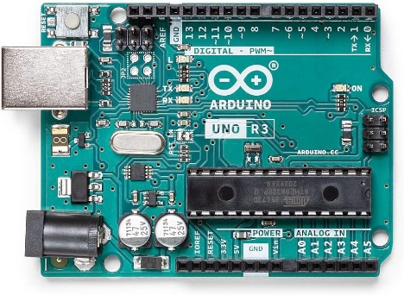

Figure 1- Arduino Uno

* **PIR motion sensor**

A PIR sensor is an electrical sensor used in motion detectors such as automatically triggered lighting devices and security systems that measure devices that emit infrared rays in their field of view.

* A PIR (Passive Infrared) motion sensor detects changes in infrared light within its field of view.
* When someone enters the room, the motion sensor detects the movement and triggers the Arduino Uno to turn on the fan.
* The motion sensor helps determine occupancy and enables the system to turn the fan on or off accordingly.

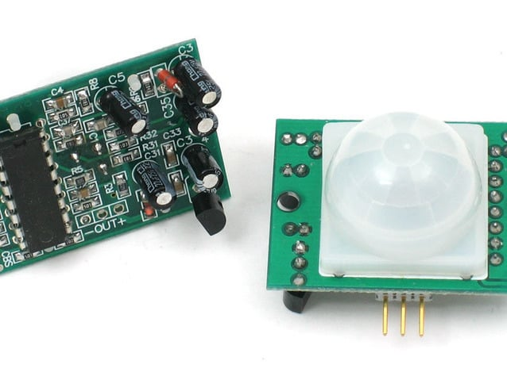

Figure 2- PIR Motion Sensor

* **Light Dependent Resistor (LDR)**

A photoresistor (also known as a photocell, or light-dependent resistor, LDR, or photoconductive cell) is a passive component that reduces the resistance to receiving luminance (light) on the sensitive surface of the component. The LDR measures the intensity of light falling on its surface.

* By monitoring ambient light levels, the LDR system helps distinguish between day and night.
* At night, when ambient light levels are low, the system keeps the lights on and sends notifications if the fan is turned on manually.

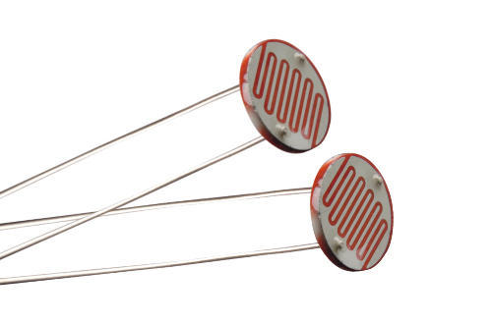

Figure 3- LDR

* **Relay module**

A power relay module is an electrical switch operated by an electromagnet. The electromagnet is operated by a separate low power signal from a microcontroller. When activated, the electromagnet is pulled to open or close an electrical circuit. The relay module acts as a switch that can control high-power devices like the fan.

* When triggered by the Arduino Uno, the relay module connects or disconnects the fan from the power source, turning it on or off accordingly.
* Isolating the low voltage control signal from the high voltage fan circuit ensures safe and reliable operation of the fan.

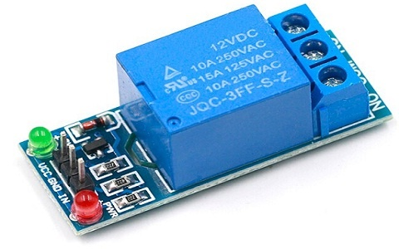

Figure 4- Relay Module

* **GSM module**

The GSM module plays a crucial role in the communication between the devices and the GSM network. It is responsible for establishing and maintaining the communication connection between the device and the network. The module also handles data encryption and decryption, thus ensuring communication security.

* The GSM module enables the system to send text messages to a pre-specified recipient (person responsible).
* It communicates with the Arduino Uno via serial communication to send notifications when specific events occur, such as turning on the fan at night.
* The GSM module provides a means of remote monitoring and alerting, improving system performance and notifying users of any relevant activity.

**Arduino Integrated Development Environments**

Arduino IDE (Integrated Development Environment) is used to write computer code and upload this code to the physical board.

In implementing our smart home system, the Arduino IDE served as the primary tool for developing the software component. Here's how we used it:

1. **Control of Fan and Sensors:**
   * Using the Arduino IDE, we developed code snippets responsible for managing the operation of the fan based on sensor inputs.
   * We programmed the logic to interpret data from sensors such as the PIR motion sensor and light dependent resistor (LDR), enabling the system to respond to changes in the environment.
   * For example, we created code snippets to turn on the fan by detecting motion through the PIR sensor or to adjust lighting conditions based on the ambient light levels sensed by the LDR.
2. **Defining System Behavior:**
   * Through the Arduino IDE, we developed a comprehensive code that defines the behavior of the smart home system according to predefined logic.
   * This involved writing scripts to direct various actions based on specified conditions, ensuring seamless operation of the system.
   * For example, we scripted logic to turn on the fan when motion is detected within specific time frames, or to trigger notifications when unusual events occur, such as the fan turning on at night.
3. **Integration with GSM Module:**
   * Using the Arduino IDE, we implemented the code to establish communication with the GSM module integrated into the system.
   * These included writing routines for sending messages to a designated recipient, usually a responsible person, when specific events required attention.
   * For example, we programmed the system to send alerts through the GSM module in situations like manually turning on the fan at night.
4. **Simplified Development Process:**
   * The Arduino IDE streamlines the process of writing, compiling, and uploading code to the Arduino board, facilitating efficient development and debugging.
   * Its intuitive interface and beginner-friendly features made it accessible even to people with limited experience in programming and electronics.

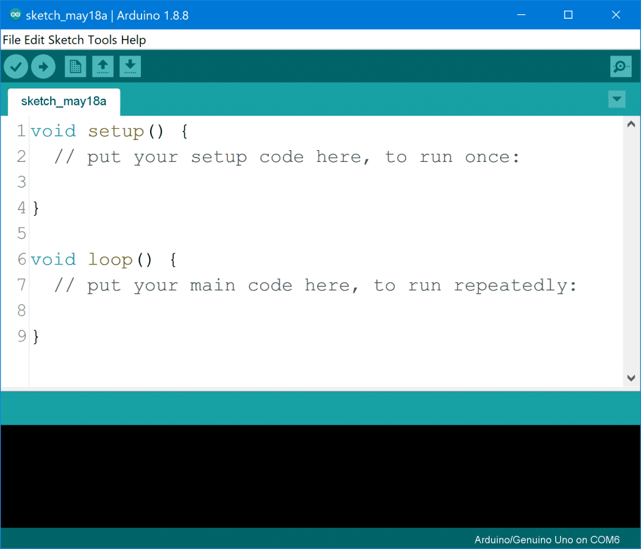

Figure - Arduino IDE

**Arduino Programming Language**

The programming language used for the smart home system is based on C/C++, commonly known as the "Arduino programming language". Here's why it's perfect for our project:

1. **Foundation:** It is built on top of C/C++, so it inherits their syntax and structure.
2. **Arduino Functions:** It includes special functions and libraries designed for Arduino boards, making it easy to interact with sensors, lights and other components.
3. **Simplified Syntax:** It is simpler than regular C/C++, making it more accessible to beginners and hobbyists.
4. **Arduino IDE:** It works seamlessly with Arduino IDE, a user-friendly software for writing and uploading code to Arduino boards.

# **CHAPTER 3- DISCUSSION**

1. **Evaluation of Sensor Accuracy and Reliability:**
   * Accuracy and reliability of PIR motion sensor and LDR in detecting occupancy and ambient light levels respectively.
   * Comparison of sensor readings with ground truth data to determine the effectiveness of sensor-based decision making in controlling fan and lighting operations.
2. **Assessment of System Responsiveness:**
   * Evaluate system responsiveness in controlling fan and lighting operations based on sensor inputs.
   * Analyzing response times and latency to assess the system's ability to adapt to rapidly changing environmental conditions.
3. **Examination of Message Delivery Reliability:**
   * Assessing the reliability of the GSM module and the timeliness in providing notifications to the responsible person.
   * Validate message delivery under varying network conditions and environmental factors to ensure consistent performance.
4. **Discussion of Implementation Challenges:**
   * Identify and discuss challenges encountered during the implementation process, such as hardware limitations, software bugs, or integration issues.
   * Analyze the root causes of these challenges and their impact on system functionality and performance.
5. **Proposed Solutions:**
   * Address identified challenges and propose solutions and mitigation strategies to improve system performance.
   * Consideration of alternative hardware configurations, software optimizations, or communication protocols to effectively overcome implementation barriers.

# **CHAPTER 4- FUTURE IMPLEMENTATION**

While the current smart home automation system successfully fulfills the project objectives, there are several avenues for further improvement and expansion. This section identifies potential areas for improvement and outlines future implementations to improve system capabilities:

1. **Integration with Additional Smart Home Devices:**
   * Explore the integration of additional smart home devices such as thermostats, door locks and security cameras to create a more comprehensive home automation ecosystem.
   * Incorporate protocols such as Zigbee or Z-Wave to enable seamless communication and interoperability between different smart devices.
   * Implement protocols and standards for device authentication and encryption to ensure security and privacy in the smart home ecosystem.
2. **Implementation of Machine Learning Algorithms:**
   * Investigate the implementation of machine learning algorithms for predictive control based on user behavior patterns and environmental data.
   * Train models to anticipate user preferences and dynamically adjust fan and lighting settings to optimize comfort and energy efficiency.
   * Explore reinforcement learning techniques to further improve automation capabilities, allowing the system to adapt and learn from user interactions over time.
3. **Enhancement of User Interface:**
   * Improve user interface for remote monitoring and control via mobile apps or web interfaces.
   * Develop intuitive and user-friendly interfaces that provide real-time status updates, historical data analysis and customization options for personalized user experiences.
   * Include features such as voice commands, geo-fencing and scheduling functionality to empower users with greater control and flexibility over their smart home environment.
4. **Integration of Environmental Sensors:**
   * Integrate environmental sensors such as temperature, humidity and air quality sensors to provide holistic monitoring and optimization of indoor environmental conditions.
   * Use sensor data to automate HVAC systems, adjust lighting levels and optimize energy use based on real-time environmental parameters.
   * Implementing alerts and notifications for abnormal environmental conditions, enabling proactive intervention and maintenance to ensure occupant comfort and well-being.
5. **Expansion of Communication Capabilities:**
   * Explore the integration of additional communication protocols such as Bluetooth Low Energy (BLE) or Wi-Fi Direct to support peer-to-peer communication between smart devices.
   * Investigate the use of cloud-based services and APIs to enable remote access, data storage and analysis, facilitate seamless integration with third-party applications and services.
   * Implement secure communication protocols and encryption techniques to protect data transmission and protect against cyber security threats.

# **CHAPTER 5- REFERENCES**

1. <https://ieeexplore.ieee.org/abstract/document/7003731>
2. <https://www.researchgate.net/profile/Nagarajan-Ramalingam/publication/315648361_Intelligent_Smart_Home_Automation_and_Security_System_Using_Arduino_and_Wi-fi/links/58db51e192851ce5e96a8594/Intelligent-Smart-Home-Automation-and-Security-System-Using-Arduino-and-Wi-fi.pdf>
3. <https://d1wqtxts1xzle7.cloudfront.net/54684423/4317eeij01-libre.pdf?1507701488=&response-content-disposition=inline%3B+filename%3DAN_APPROACH_TO_SMART_HOME_SECURITY_SYSTE.pdf&Expires=1711565400&Signature=VB2REFwQqaLpQ6lpaPJGhqpg~69yr9OByQbiuOR3P5z1GLMw9XzT4Zh6lZ4kxZ1P42O-r1UacPNe8bGEe5ZxiPwag93wTE473yneM8Df9YboVpKGv1pjuXQ-uPVZbIUsHMkDaUAdpTmMbDEPZSgXiFBhySGU8JMJIGjPeqWUFEUnu2FUrUMAhzwQQLTVyAWm~JFsB29iFBJRSFDmKvFKtTAxuj06O1Ct1Wxy5Q95B2TAtcJtg9Js4ML1AbuxlaX-bPsEE51WbZmbuZ3qqDvHw5dRGsrL8PmxzALvKibPquukFWUwLDbYSVeF2t8bcGsitlMySF4uZ83IFyqbcDRFBA__&Key-Pair-Id=APKAJLOHF5GGSLRBV4ZA>
4. <https://d1wqtxts1xzle7.cloudfront.net/56008096/IRJET-V5I2296-libre.pdf?1520586937=&response-content-disposition=inline%3B+filename%3DSmart_Home_Automation_and_Security_Syste.pdf&Expires=1711566126&Signature=gYC-NnuzM5ky1Fbb1XkYGoI2kjs7547CvXulMPfsP-ki5Ra1gODIIErVDD-bYf64yIjeL9iT5uxOSFH5lHweq-kxGGeYBlFH-bdY0CPE~V3Et2DUjsG7QQYrLjRfz9yfwALTymoyh811KzF2EaP5mRESEEX8Qx-rfXpx4z9m0jJfiaEVWz95UeoG0irQ0M5WRHT2NlpkmjQax6O2Jr3amGY6ARss476B2il7uNOgQDVyRW1WQlds7pig63wHSSE8UcyBVqc808JE-h2k76u3BzoMbFJvTSHzgkMa~GRll~DmBflQeTLNzcu347JBtUbCcUmmfFlpKSQDFgFPNsr9sw__&Key-Pair-Id=APKAJLOHF5GGSLRBV4ZA>
5. <https://cdnx.uobabylon.edu.iq/research/HHd2HhzS90GUf8MuOeg.pdf>

# **CHAPTER 6- GANTT CHART**

Figure 6-Gantt Chart